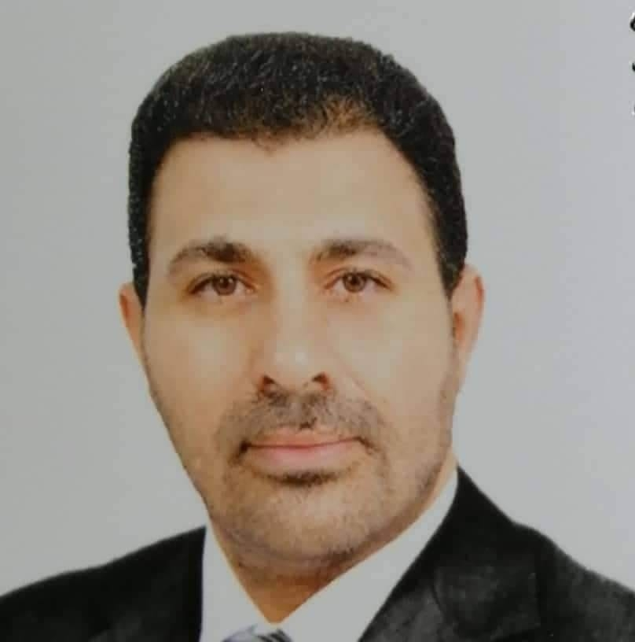 |  |  |  | Bilal A. AHMED  Academic qualification: Ph.D. in biomechanics
General specialty: Physical education and sports science
Specialist in Biomechanics: Kinesiology
1- Kinetic analysis 2- Analysis Body force 3-motor skills activities
Sincerely,
Current work: Assistant Prof at Ibn Sina university of Medical and Pharmaceutical Sciences, College of Medicine, Basic Sciences...
Researches
- Neuromuscular compatibility exercises with electrical stimulation and their effect on some biomechanical variables and the achievement of hammer throwing
- Calculated calories for training and their effect on developing some physical and biomechanical abilities and achieving 400-meter run for youth
- The Relation of the Motive Sport Achievement and Self-confidence with the Level of Achievement of Throwing Events in Athletics
- Special Training According to Power Law and Its Effect on Some Kinetical Indicators and Achievement in 100m Sprint Under 20 Years Old
- The Momentary Strength Exercises and The Strength Distinguished by Speed with Electrical Stimulation (Ems) And Its Effect on Some Biomechanical Variables and Achievement of Hammer Throw
- Ballistic training and its effect on the values of some kinematic variables and the electrical activity values of working muscles and the achievement of discus throwing for juniors
- Effect of Muscle Balance Exercises in (EMG) and some Biomechanical Variables Hammer throw
- Impact strength exercises for the muscles involved in some variables Biomechanical And completion of payment of gravity
- تأثير تدريبات خاصة وفق جهاز الكتروني مصنع في التحكم بتوازن القوة للرجل الامامية والخلفية أثناء التقدم والرجوع في رياضة المبارزة
- device (F & T1) for measuring the force and pull of the trigger

Date of birth: 10/11/1972
Nationality: Arabic
Religion: Muslim
 |  | Iraq Baghdad
 |  | (dr.bilal@ibnsina.edu.iq)

